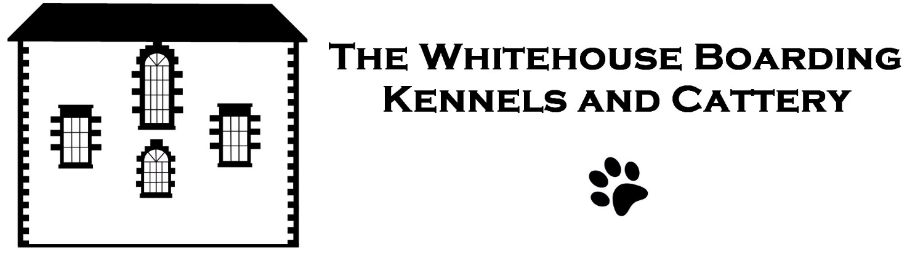
Booking Application Form
I accept The Whitehouse Kennels terms and conditions of boarding as shown on their website and wish to board my pet(s). I understand that The Whitehouse Kennels will store and process my personal information (please see http://www.thewhitehousekennels.co.uk/privacy-policy/ for details).
From: Click here to enter a date. To: Click here to enter a date.
Owner's name: Click here to enter text.
Address: Click here to enter text.
Tel home: Click here to enter text. Mobile: Click here to enter text.
Pet Name(s): Click here to enter text.
Breed and Description: Click here to enter text.
Food: Choose an item.
Usual Veterinary Surgeon: Click here to enter text.
For dogs only: I am happy for my pet(s) to be exercised and socialised with other dogs: ☐
I give consent for my dog(s) to be exercised off Whitehouse premises: ☐
If you’ve asked for your dogs to share a kennel, please confirm this here: ☐
Pickup and/or delivery required: ☐ (We’ll need to call you to confirm the details)
No pet will be accepted without a current vaccination certificate.
I understand that while every care will be given to my animal(s) they are boarding entirely at my own risk. I authorise you to call a veterinary surgeon on my behalf should it become necessary. All fees should be up front and accept that the boarding fee will not be refunded should I collect my animal(s) before the due date.
If an animal is not collected within 15 days of its departure date and no communication from the owner or their agent has been received and our efforts to contact the owner have failed, The Whitehouse Kennels reserve the right to treat such animals as having been abandoned and to take the necessary steps to have the animal removed from our premises and dealt with appropriately. The animal's owner will be liable for any additional expenses incurred.
Email completed form to: info@thewhitehousekennels.co.uk

Signed: ………………………….……………………………………….. Date: ………………………………

